TECHNICAL ANALYSIS

# SIMPLE MOVING AVERAGE:-

A **simple moving average** (SMA) is an arithmetic **moving average** calculated by adding the closing price of the security for a number of time periods and then dividing this total by the number of time periods.

## Formula:-

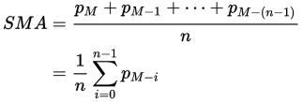

## Code:-

## Graph:-

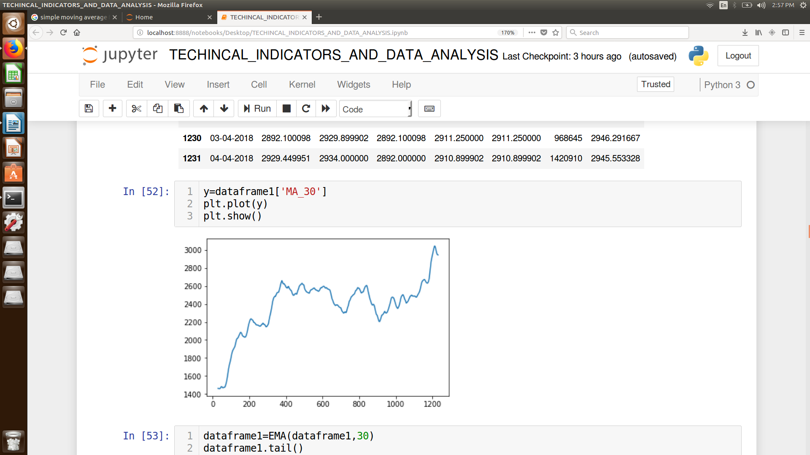

# EXPONENTIAL MOVING AVERAGE:-

An **exponential moving average** (EMA) is a type of **moving average** that is similar to a simple **moving average**, except that more weight is given to the latest data. It's also known as the **exponentially weighted moving average**. This type of **moving average** reacts faster to recent price changes than a simple **moving average**.

## Formula:-

## Code:-

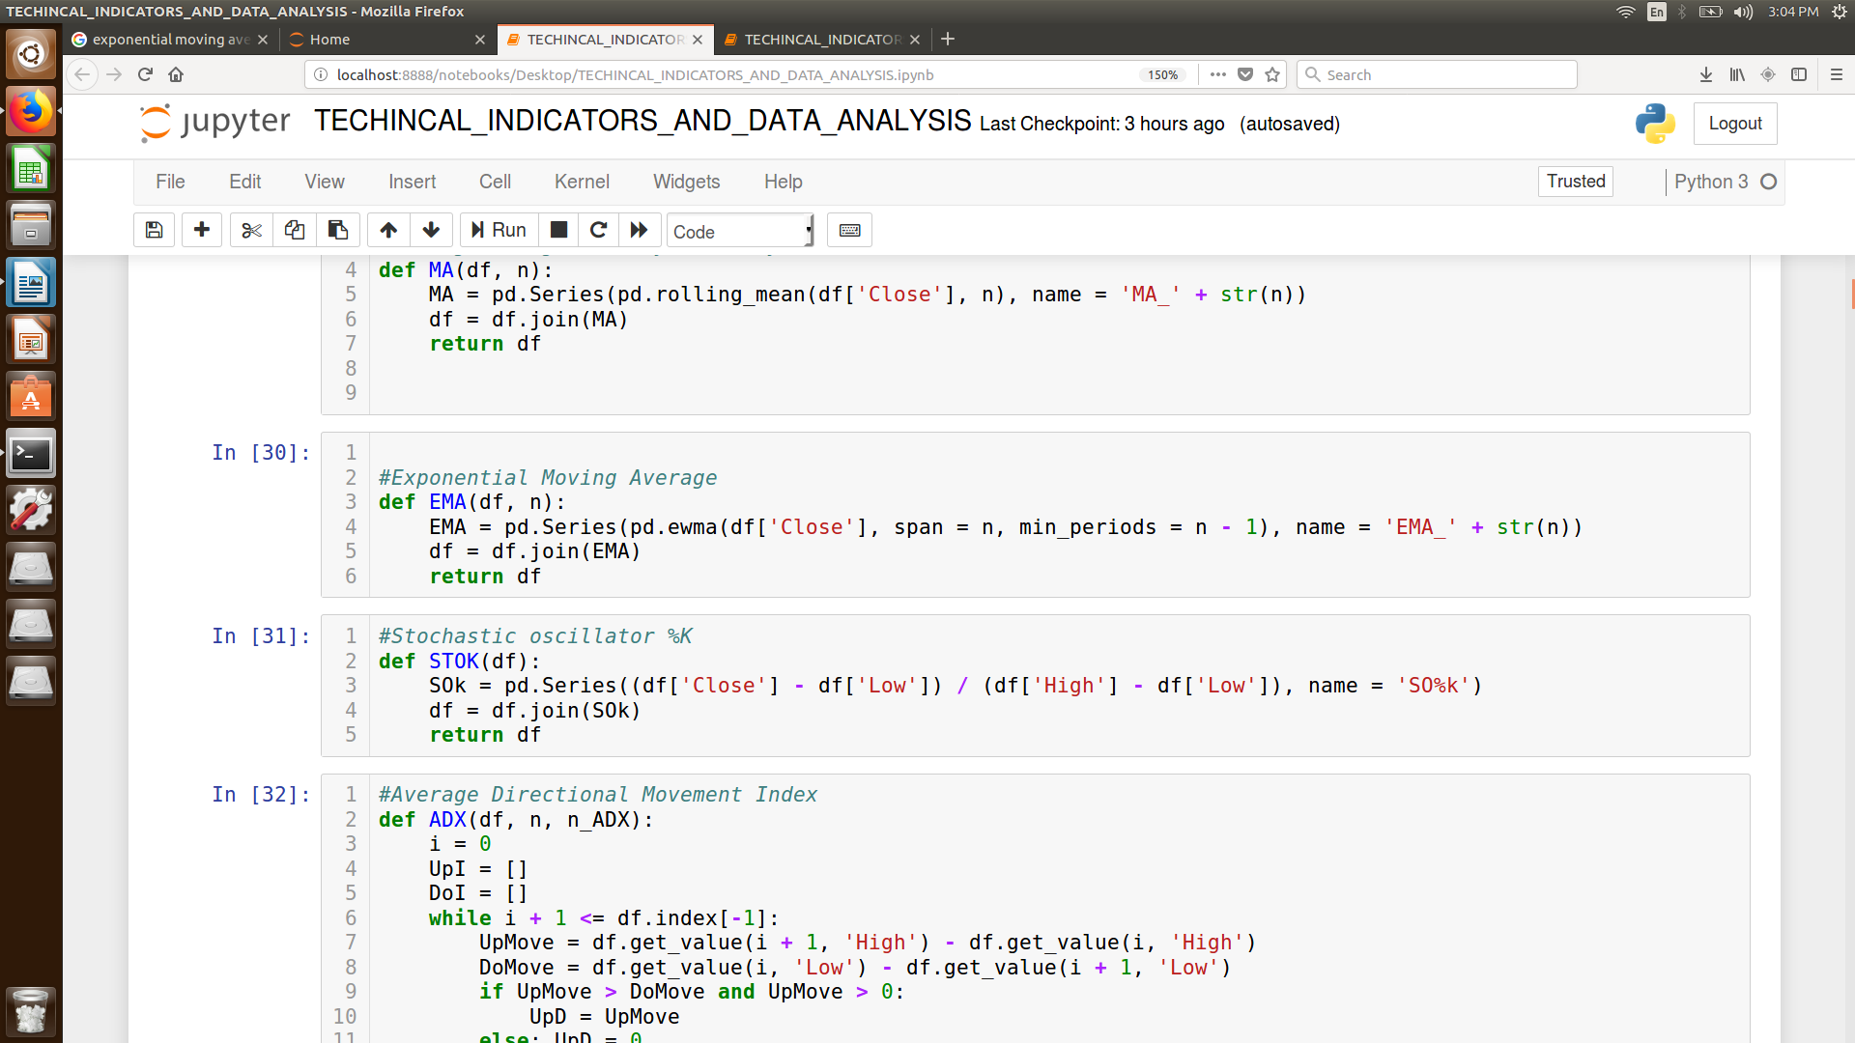

## Graph:-

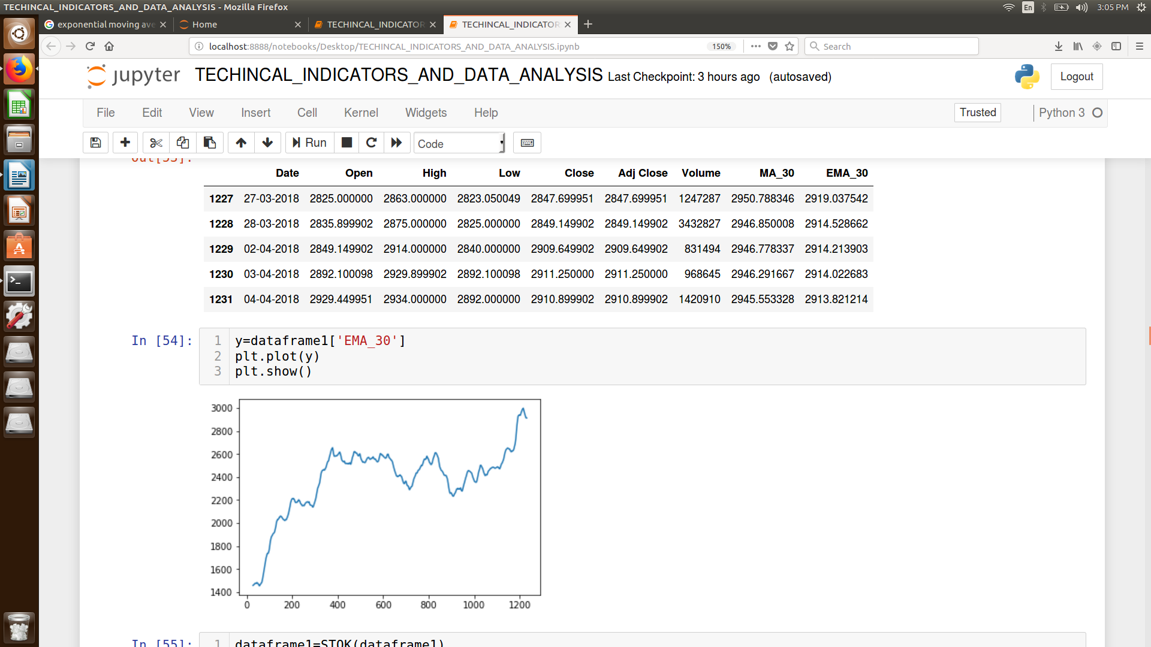

# Stochastic oscillator %K :-

The stochastic oscillator is a momentum indicator comparing the **closing price** of a security to the range of its prices over a certain period of time. The sensitivity of the oscillator to market movements is reducible by adjusting that time period or by taking a **moving** **average** of the result.

## Formula:-

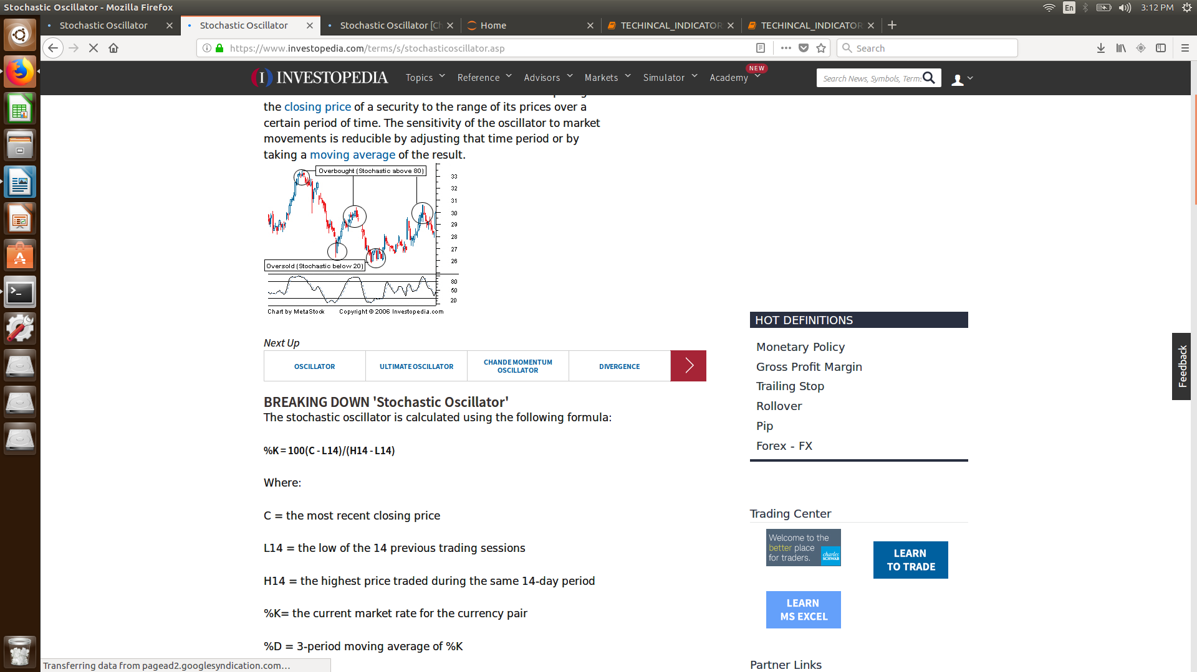

## **Code:-**

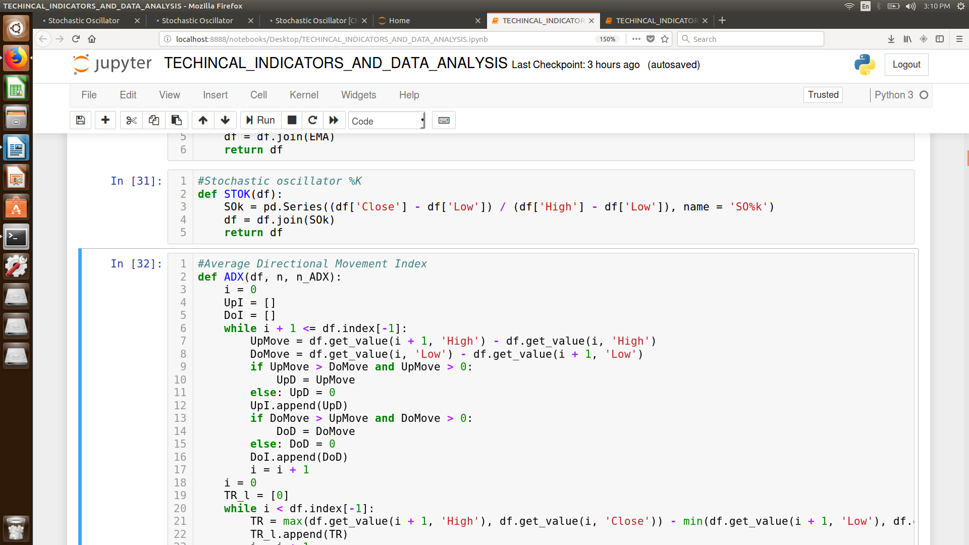

## Graph:-

# 

# Average Directional Movement Index:-

Average Directional Movement Index or ADX is used to quantify trend strength. ADX calculations are based on a **moving average** of price range expansion over a given period of time. The default setting is 14 bars, although other time periods can be used. ADX can be used on any trading vehicle such as stocks, mutual funds, **exchange-traded funds** and futures.

## Formula:-

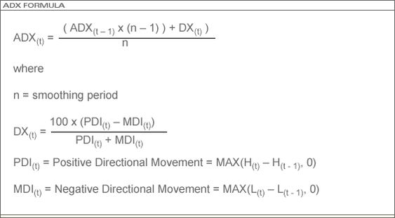

## CODE:-

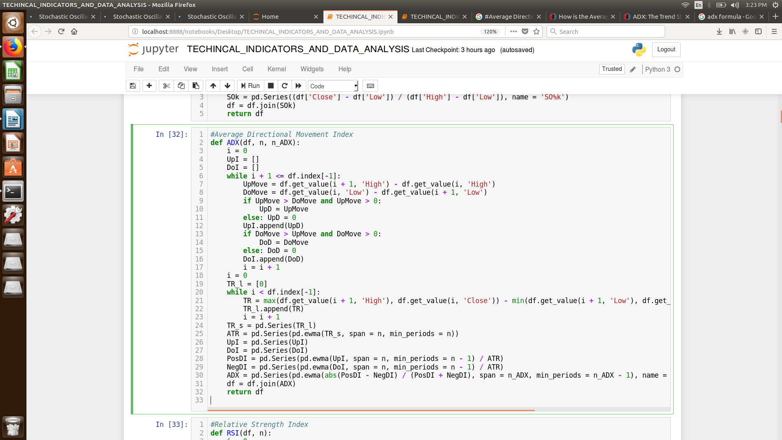

## Graph:-

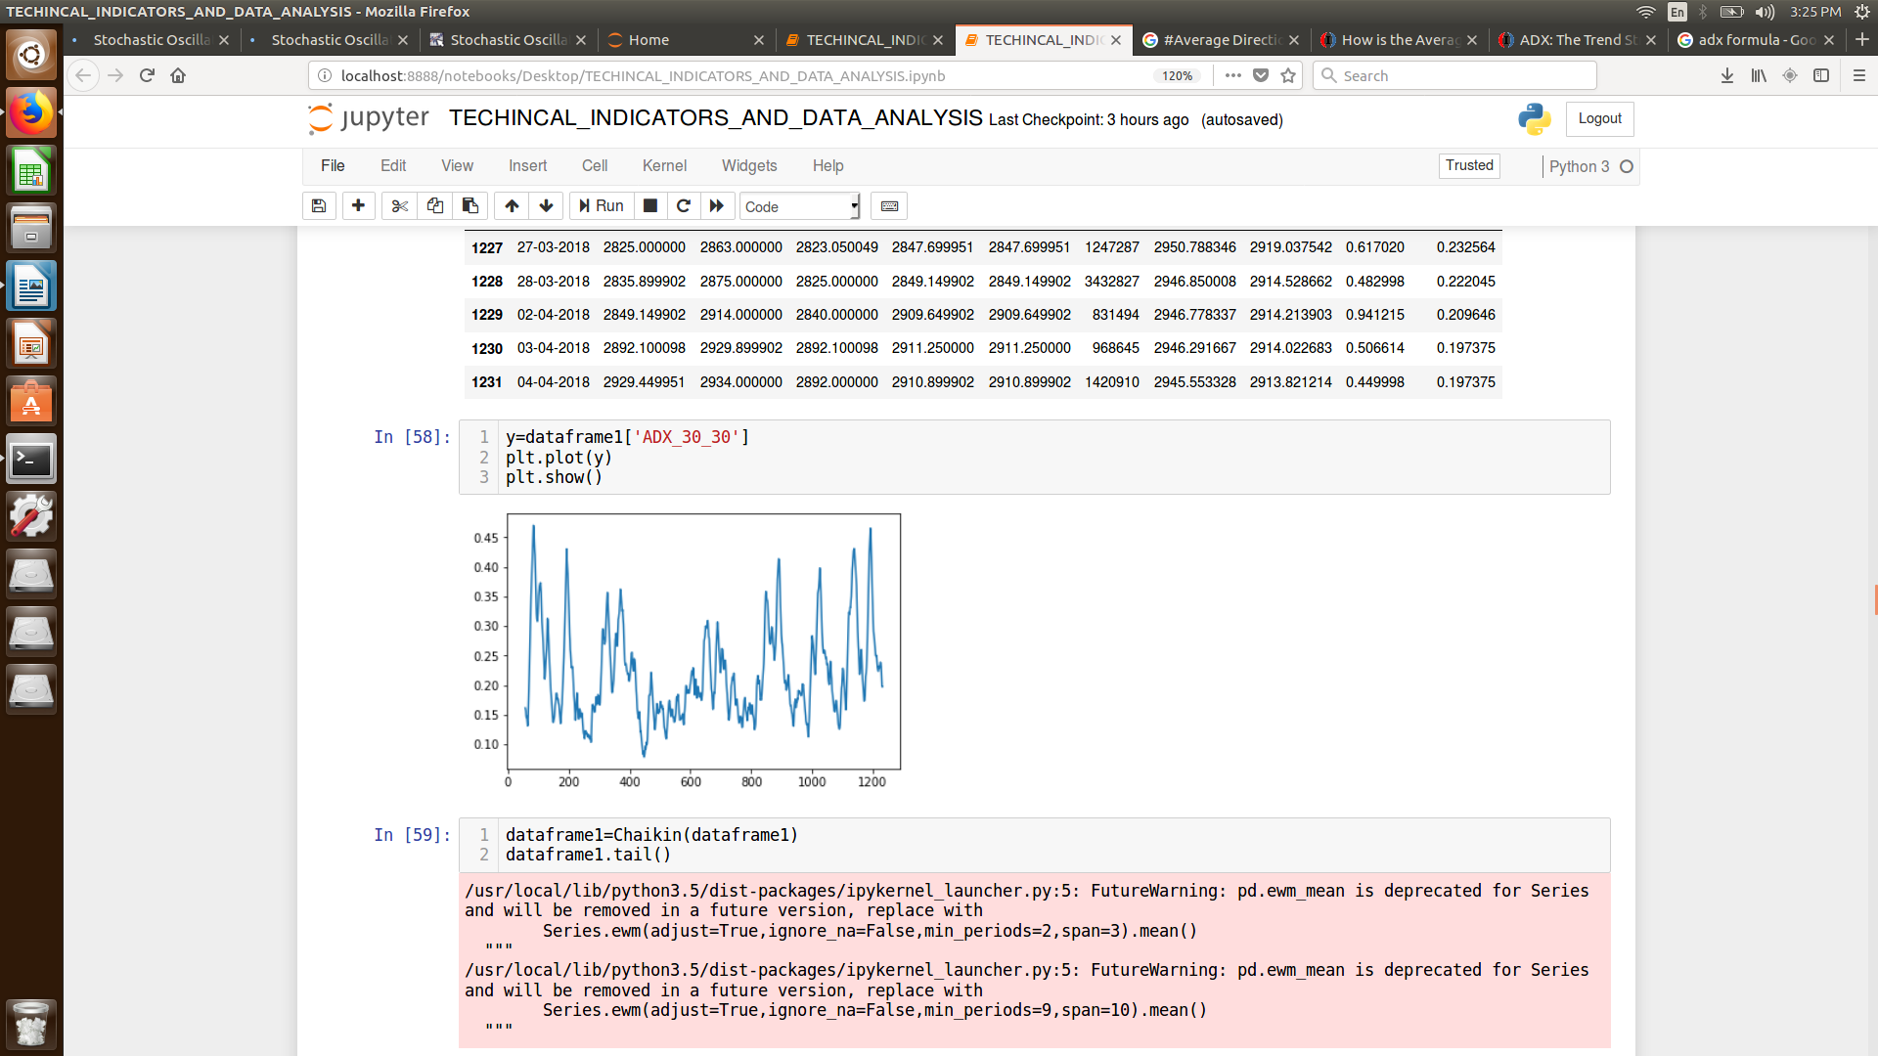

# Chaikin Oscillator:-

The **Chaikin Oscillator** is the difference between the **3-day EMA** of the Accumulation Distribution Line and the **10-day EMA** of the Accumulation Distribution Line. Like other momentum indicators, this indicator is designed to anticipate **directional changes** in the Accumulation Distribution Line by measuring the momentum behind the movements. A momentum change is the first step to a trend change.

## Formula:-

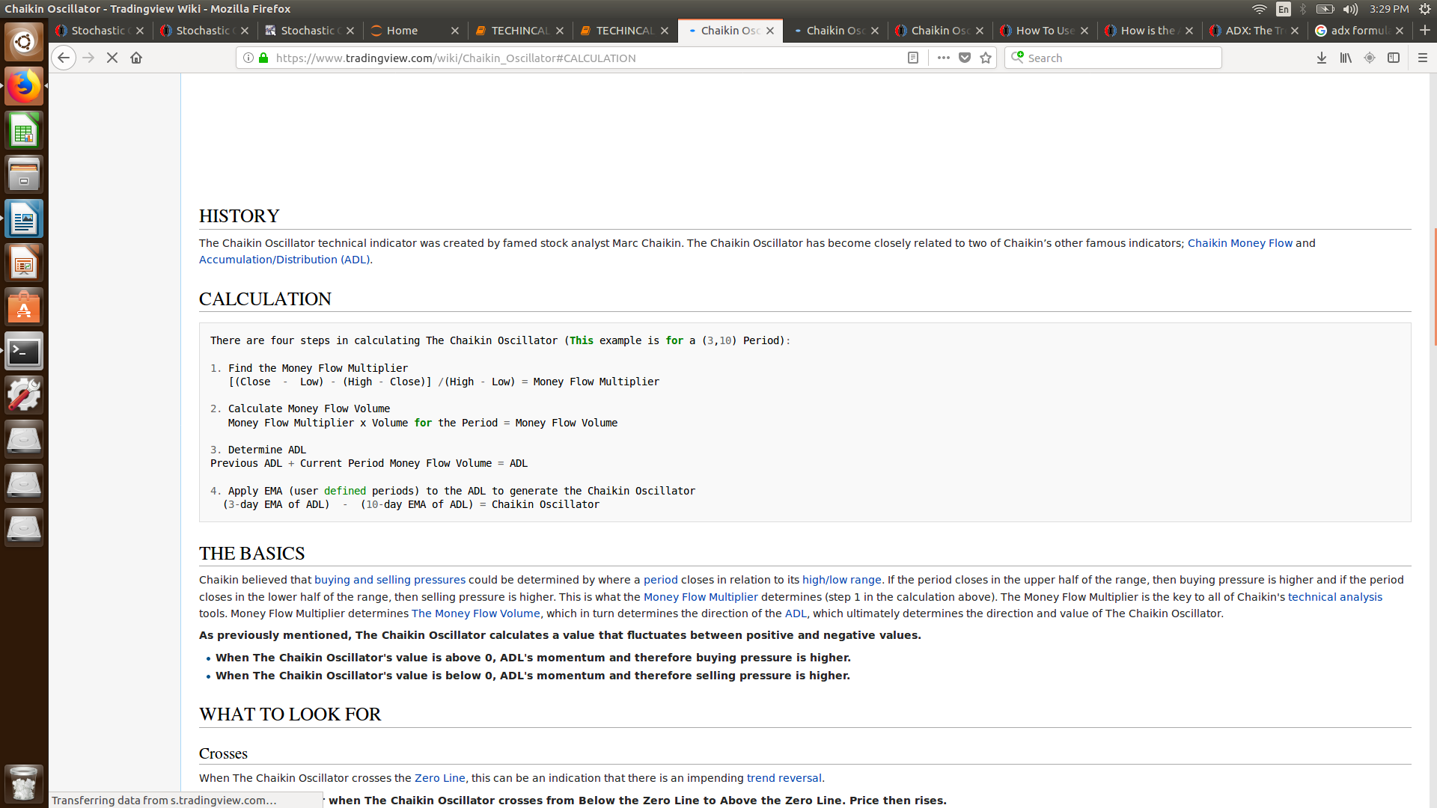

## Code:-

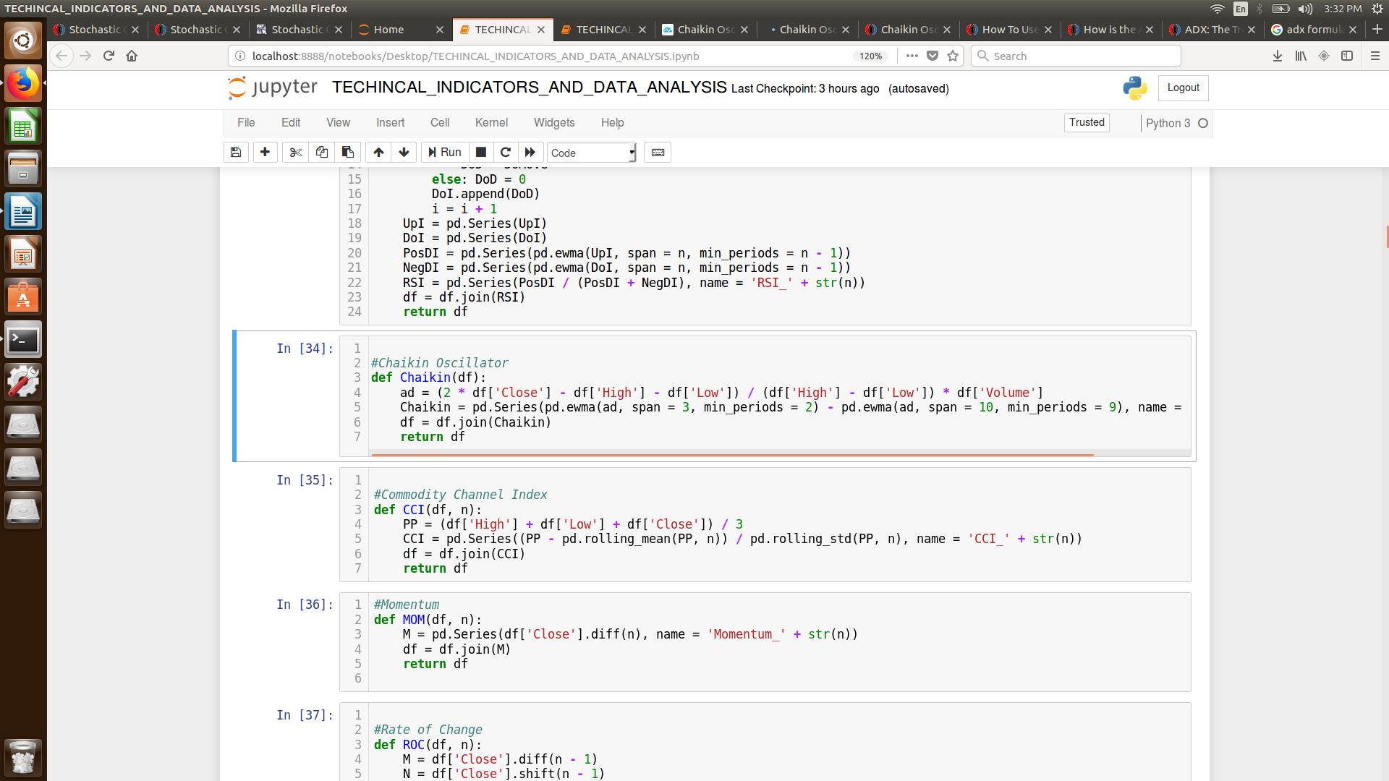

## Graph:-

# Commodity Channel Index:-

Commodity Channel Index (CCI) is a versatile indicator that can be used to identify a new trend or warn of extreme conditions.CCI measures the current price level relative to an **average price level** over a given period of time. CCI is relatively high when prices are far above their average. CCI is relatively low when prices are far below their average. In this manner, CCI can be used to identify **overbought** and **oversold levels.**

## Formula:-

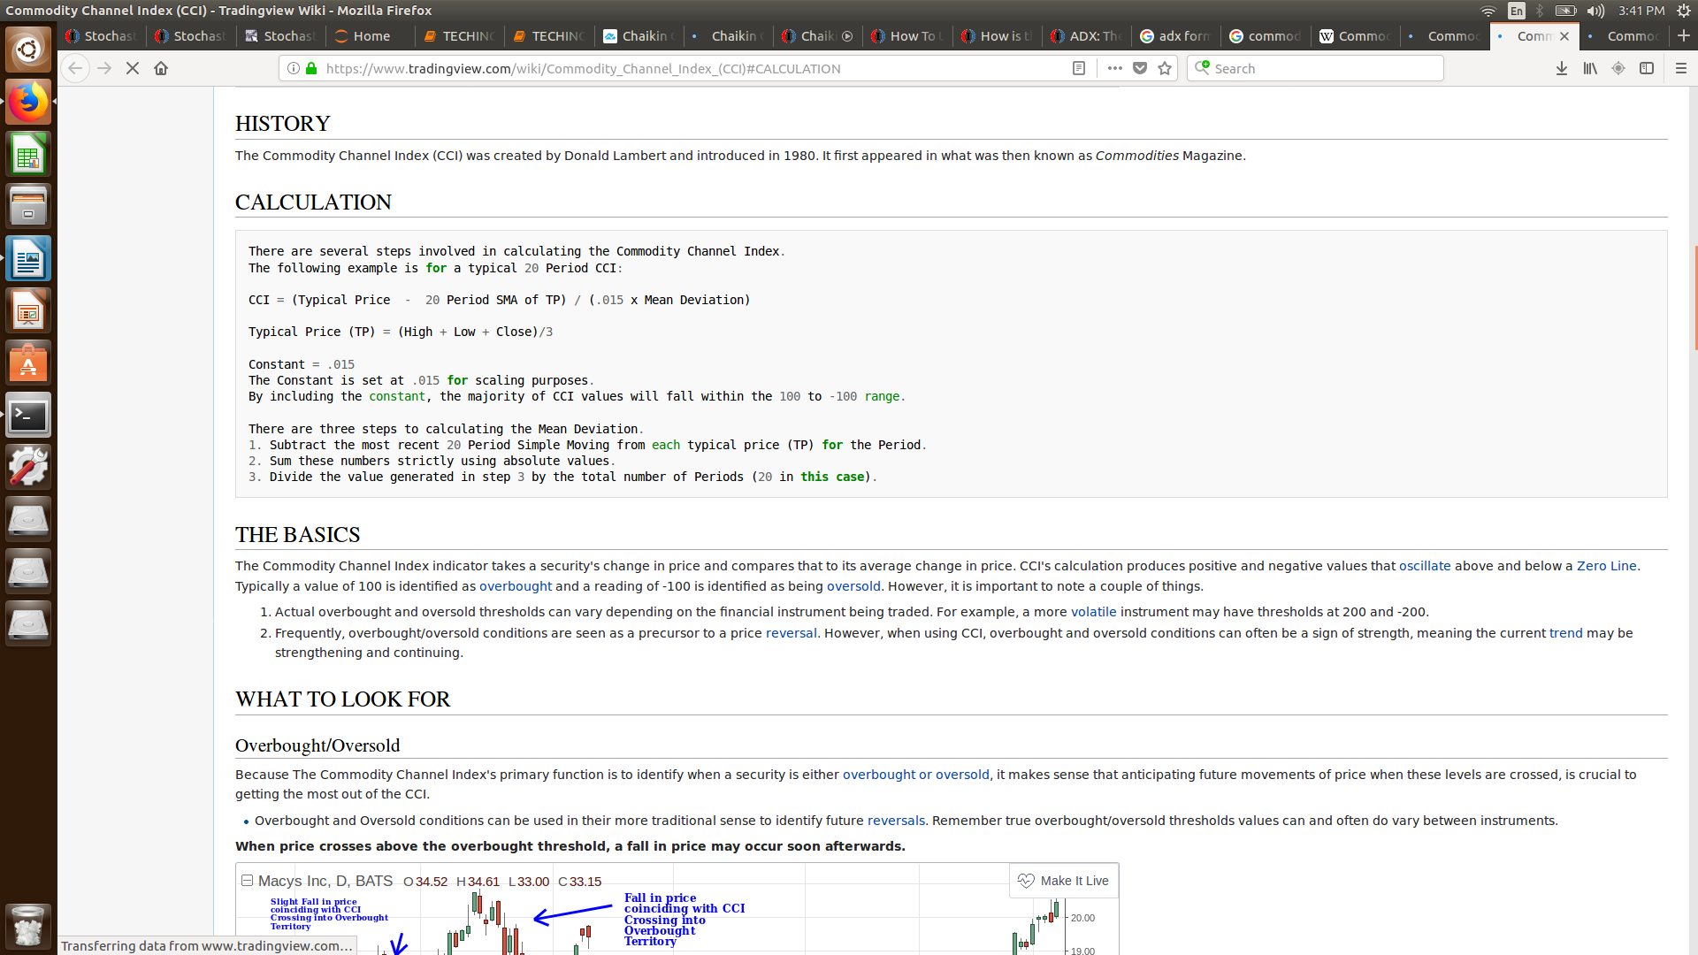

## Code:-

## 

## Graph:-

## 

# Momentum:-

The **Momentum indicator** is a speed of movement **indicator** designed to identify the speed (or strength) of price movement. The **momentum indicator** compares the most recent closing price to a previous closing price (can be the closing price of any time frame).

## Formula:-

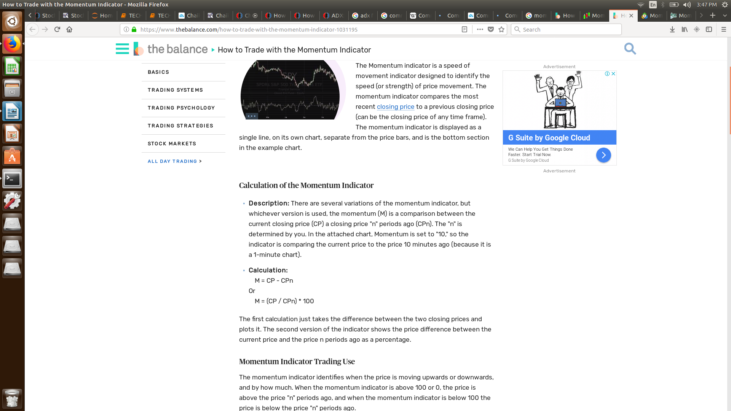

## Code:-

## Graph:-

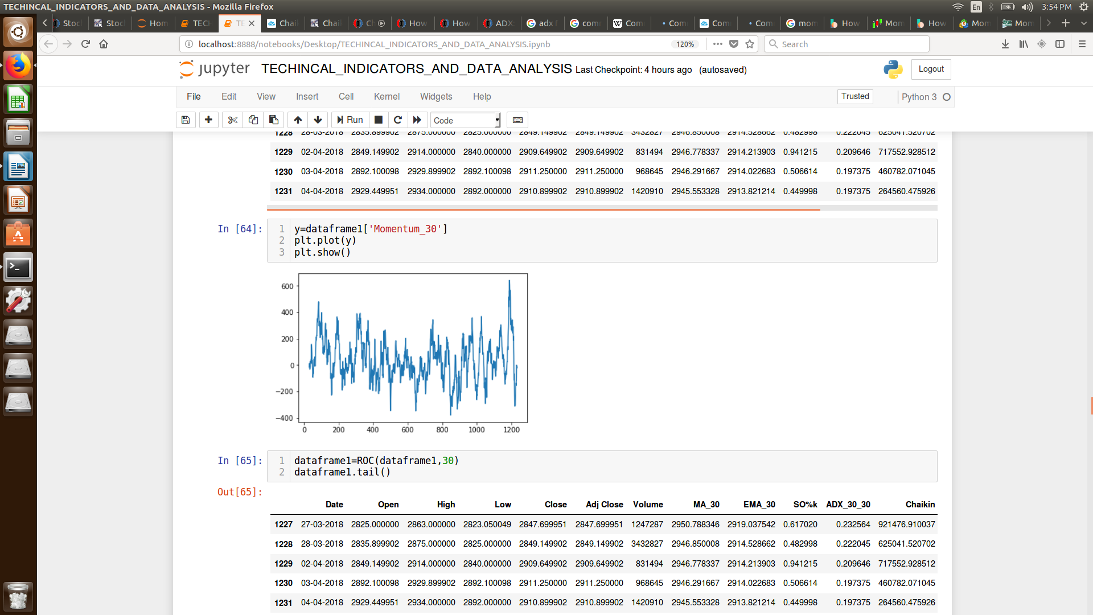

# Rate of Change:-

The **Rate-of-Change** (ROC) **indicator** is a pure momentum oscillator that measures the percent **change** in price from one period to the next. The ROC calculation compares the current price with the price “n” periods ago.

## Formula:-

## 

## Code:-

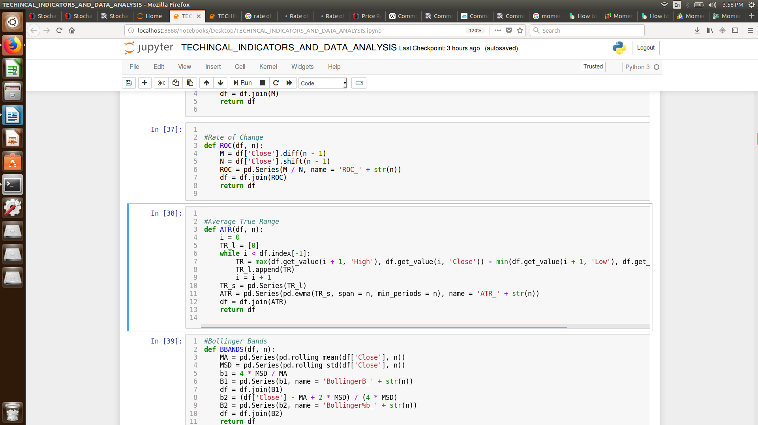

## Graph:-

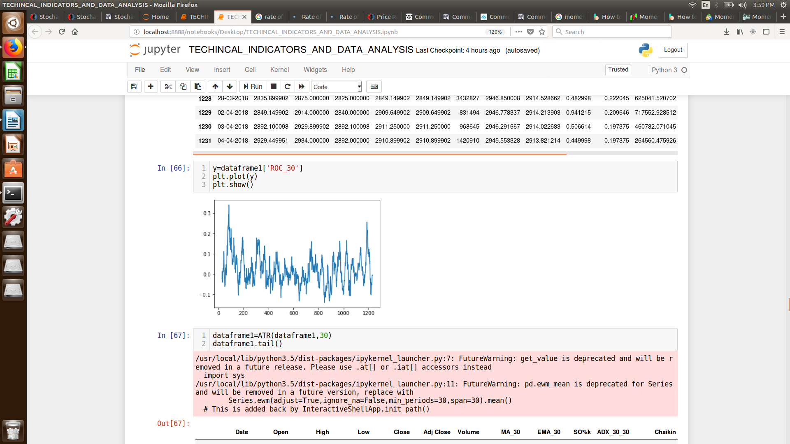

# Average True Range :-

The average true range (ATR) is a measure of volatility. The true range indicator is the greatest of the following: current high less the current low, the **absolute value** of the current high less the **previous close** and the absolute value of the current low less the previous close. The average true range is a **moving average**, generally 14 days, of **the true ranges.**

## Formula:-

## 

## Code:-

## 

## Graph:-

